**VELAMMAL ENGINEERING COLLEGE**

**ELECTRONICS AND COMMUNICATION ENGINEERING**

**SMART FARMERS - IOT ENABLED FARMING**

**APPLICATION**

**ASSIGNMENT – 4**

**BY:**

Nandhini V

(113219041072)

# Question:

**WRITE CODE AND CONNECTIONS IN WOKWI FOR ULTRASONIC. WHENEVER DISTANCE IS LESS THAN 100 CMS SEND “ALERT” TO IBM CLOUD AND DISPLAY IN DEVICE RECENT EVENTS.**

**CODE:**

#include<WiFi.h>//libraryforwifi#include<P ubSubClient.h>//libraryforMQtt

#defineECHO_GPIO12 #defineTRIGGER_GPIO13

#defineMAX_DISTANCE_CM100//Maximumof5meters#include"Ultra sonic.h"

Ultrasonicultrasonic(13,12);int distance;

voidcallback(char*subscribetopic,byte*payload,unsignedintpayloadLength);

//-------credentialsofIBMAccounts------

#defineORG"dv1snq"//IBMORGANITIONID #defineDEVICE_TYPE"ESP32"//DevicetypementionedinibmwatsonIOTPlatform#define DEVICE_ID "12345"//Device ID mentioned in ibm watson IOT Platform#defineTOKEN"45682367915"//Token

Stringdata 3;floath,t

;

//--------Customisetheabovevalues--------

char server[] = ORG ".messaging.internetofthings.ibmcloud.com";// Server Namechar publishTopic[] = "iot-2/evt/Data/fmt/json";// topic name and type ofeventperform andformatinwhich datato besend

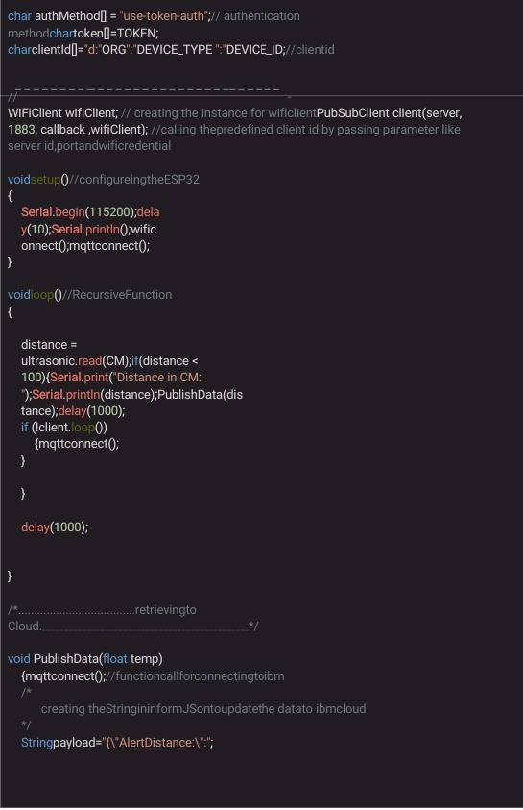

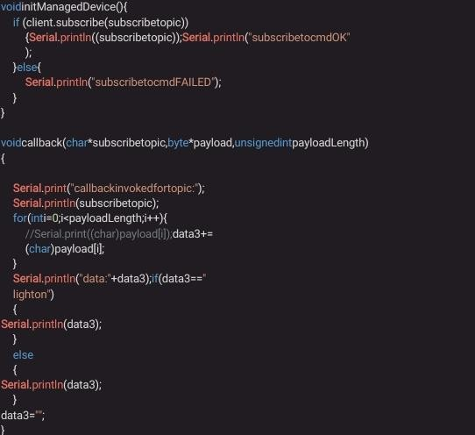

**OUTPUT**

